1. (20 points) Compressed images when K = 5, 30, 100 (15 points).
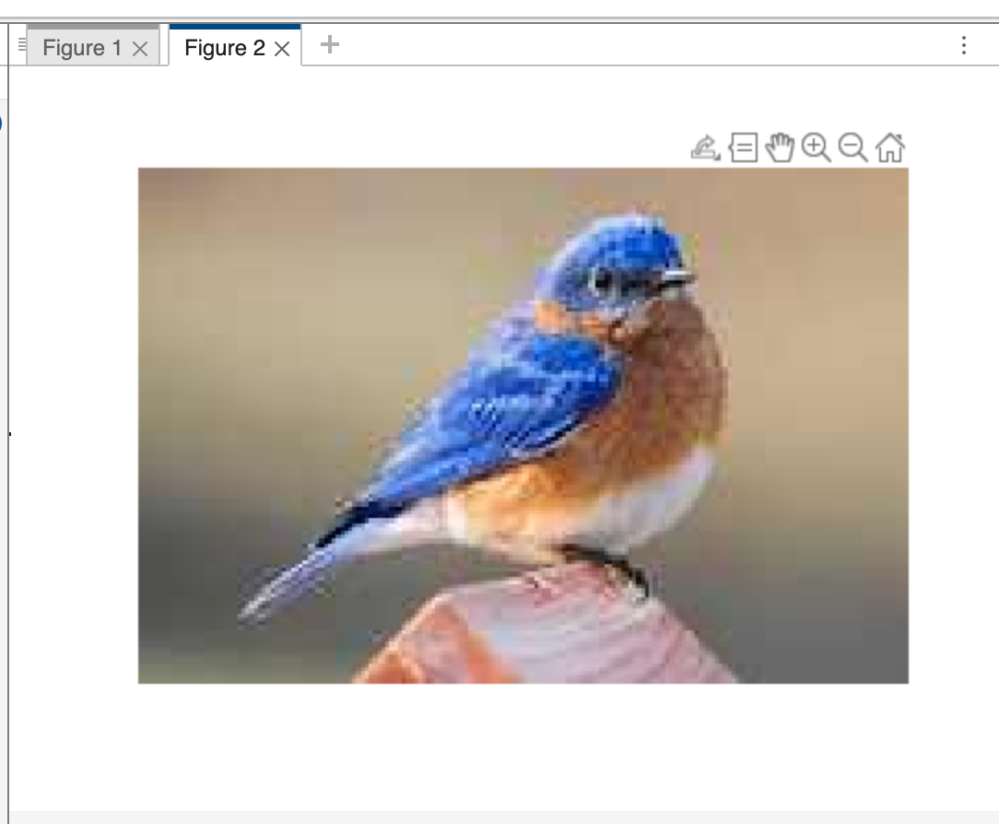
K = 100

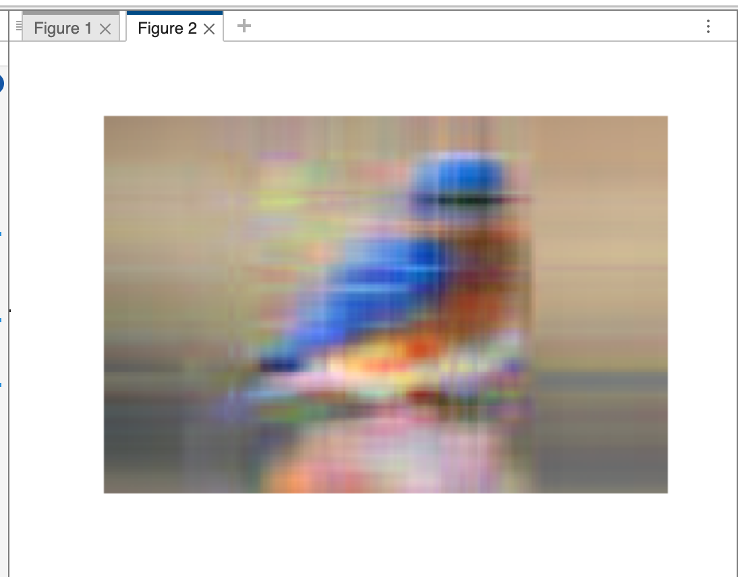
K = 5

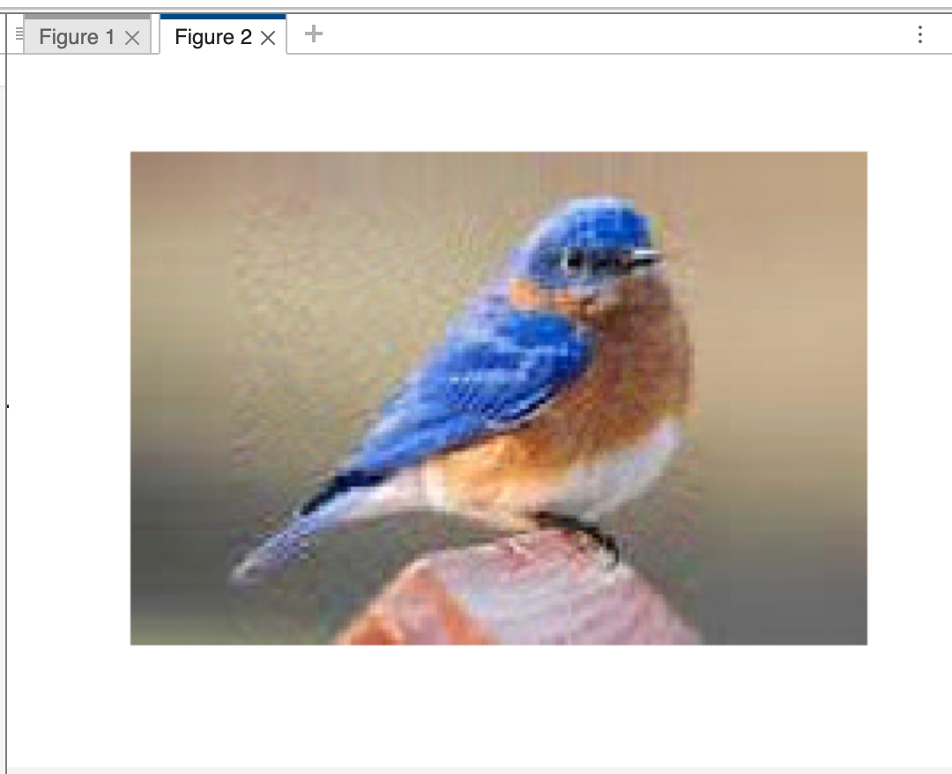
K = 30

Increasing K improves the image quality as more features are being retained during image reconstruction.

2. (5 points) Describe what have gone well and what have not gone well during the implementation. Also describe how your current implementation can be potentially improved to achieve better performance.

I was initially having trouble scaling the pixel values as I was getting “unsupported” calculation type but once I used the (double) typecast the issue was resolved. This was a very fun lab with practical applications.

